Practical Software and Systems Measurement Continuous Iterative Development
Measurement Framework
Part 2: Measurement Specifications: Cycle Time/Lead Time

Version 2.1
April 15, 2021

Developed and Published by Members of:

Practical Software & Systems Measurement | National Defense Industrial Association | International Council on Systems Engineering
Product No.  PSM-2021-03-001 |  | Product No.  INCOSE-TP-2020-001-06

Editors:
Cheryl L. Jones  US Army  cheryl.l.jones128.civ@mail.mil |  | Geoff Draper  L3Harris Technologies  geoff.draper@l3harris.com
Bill Golaz  Lockheed Martin  willliam.h.golaz@lmco.com |  | Paul Janusz  US Army  paul.e.janusz.civ@mail.mil

Unclassified: Distribution Statement A: Approved for Public Release; Distribution is Unlimited

PSM Product Number: PSM-2020-06-001
INCOSE Product Number: INCOSE-TP-2020-001-06

Copyright Notice:
For this document, each of the collaborative organizations listed on the cover page is the sole manager of their products and services and are the only parties authorized to modify them. Since this is a collaborative product, modifications are managed through the participation of all parties.

General Use: Permission to reproduce, use this document or parts thereof, and to prepare derivative works from this document is granted, with attribution to PSM, NDIA, and INCOSE, and the original author(s), provided this copyright notice is included with all reproductions and derivative works.

Supplemental Materials: Additional materials may be added for tailoring or supplemental purposes if the material developed separately is clearly indicated. A courtesy copy of additional materials shall be forwarded to PSM (psm@psmsc.com, attention: Cheryl Jones). The supplemental materials will remain the property of the author(s) and will not be distributed, but will be coordinated with the other collaboration parties.

Author Use: Authors have full rights to use their contributions with credit to the technical source.

Supplemental Notice from INCOSE: This work is an Affiliate Product per INCOSE Policy TEC-107 INCOSE Technical Product Development & Commercialization (26 October 2018). It is a technical product developed outside the INCOSE product development process and was made by INCOSE members in cooperation with PSM and NDIA; then approved by INCOSE to be distributed from INCOSE central channels. The authors own the copyright and take primary responsibility for proper branding, intellectual property, content quality and appropriate citations with INCOSE oversight based on this policy & related procedure.

Contents
8. Measurement Specifications 1
8.5 Cycle Time/ Lead Time (Team or Product Measure) 1

List of Figures
Figure 1: Cycle Time: Closed Issues 2

Measurement Specifications

Cycle Time/ Lead Time (Team or Product Measure)
Measure Introduction
Description | 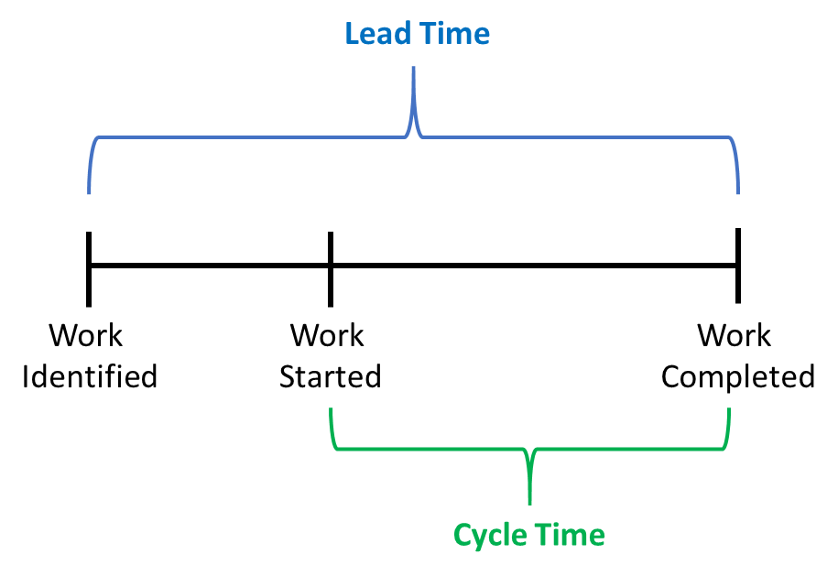  Cycle Time and Lead Time can be used to evaluate efficiency in developing work products and as predictors for estimating future work. Cycle Time and Lead Time are similar and related measures that determine the duration for completing new work or products. The differences are in when start times are measured, as depicted in the diagram to the right, and described further below.  Refer also to Figure 2, Measurement Context Diagram.
Relevant Terminology | Cycle Time The elapsed time from when work is started until the time work has been completed. (e.g., Capability, Feature, Story, Defect). Cycle Time is expressed in terms and context of the team capability. It is typically targeted at measuring repeatability and predictability of team performance for well-scoped work so that results are comparable across multiple similar efforts (stories, features, capabilities). It often excludes the up-front effort needed to define and prepare the work to be implemented, such as backlog, prioritization, planning, requirements analysis, design.  Lead Time Similar to cycle time but is expressed in terms and context of the user or stakeholder perspective. It is measured from the time work is identified and a request is provided to the time until the time it is satisfied. Lead Time includes these up-front necessary activities such as backlog, prioritization, planning, requirements analysis, and design.  Lead Time, Cycle Time (and Release Frequency) are closely related measures calculated similarly. The primary difference is in the information need and objective (repeatable team performance vs. user/stakeholder need) which can drive when the start/end times are measured for various activities. Lead Time may also be used to measure a higher-level aggregate business need, as opposed to Cycle Time which may measure the base elements needed to ultimately satisfy that business need.

Information Need and Measure Description
Information Need  (Cycle Time) | How long does it take to release a viable product (team, product, enterprise)
Information Need  (Lead Time) | How long does it take to deploy an identified feature/capability, once a request is submitted? (product)
Base Measure 1 | Start time for a process activity (date and time)
Base Measure 2 | End time for a process activity (date and time)
Derived Measure 1 | Elapsed Time = (End Time – Start Time) + 1  (Units may vary based on team context, capability, cadence; e.g., hours, days, weeks, months.  May also vary based on calendar time vs. work days. Results with fractional values are rounded up to the next unit.)  Examples:  1: Cycle Time = 08/21/2019 – 08/20/2019 = 2 days  2: Cycle Time = Fri 09/13/19 – Mon 09/02/19 = 12 calendar days = 10 workdays = 2 work weeks  3. Cycle Time = 09/01/19 12:52 – 09/01/19 08:05 = 5 hours  4. Lead Time = 08/31/19 – 6/15/19 = 78 calendar days

Indicator Specification
Indicator Description and Sample | 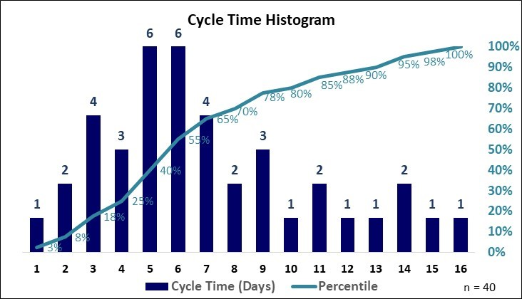  Figure 1: Cycle Time: Closed Issues  Cycle time performance is frequently analyzed in histograms as depicted in Figure 1. In this example, work items complete in 4 days or less only 25% of the time; 80% of work items complete in 10 days or less; 90% of work items complete in 13 days or less. Analyses such as this can be used to define and monitor process performance objectives, such as service level agreements.  Other tools and charts are also common in industry, but typically include information such as:  - Plots of cycle time or lead time measures for software deliveries over a defined time range.  - Statistical analysis of process performance measures (e.g., mean, median, rolling average, standard deviation)
Analysis  Model | Analysis of Cycle Time or Lead Time measures can indicate process performance trends or potential indicators of issues for root cause analysis and performance improvement. Example analyses may include:  - Process efficiency and stability (increase/decreasing delivery times or throughput)  - Predictability for future performance (narrowing or widening standard deviation in delivery outcomes)  The analyst may consider questions such as:  - Is the cycle time consistent across iterations?  - Is cycle time increasing or decreasing?  - Do the cycle time and lead time performance (Voice of the Process) meet the business need (Voice of Customer)?  - How predictable is the release cycle? Can we reliably estimate future performance?  - What are the root causes for process outliers?  - Are process improvements effective?  - Are any corrective actions needed to bring performance in line with expectations?  Shorter cycle times can indicate effective delivery flow and quicker time to market. Longer cycle times are often correlated to the number of items for Work in Progress (WIP). Consider moderating attributes of the assigned work and resources in order to achieve predictable performance. Tuning small batch sizes for WIP is a common approach used to achieve a consistent delivery cadence.  Teams should implement improvements to bring capability and performance in alignment with the business need. Lead times and release frequency can be optimized by managing backlog depth to reduce latency of critical capabilities or applying additional resources to work concurrently.
Decision Criteria | Investigate outliers for cause of variations. Review each outlier that is more than 10% from the average cycle time.

Additional Information
Additional Analysis Guidance | Under consistent conditions, cycle time and lead time can be used as measures of team capability and throughput that can be used in lieu of traditional size-based productivity measures (such as lines of code / hour). Reductions in cycle time and lead time measures can indicate faster delivery to the customer, which yields additional potential business benefits such as:  - Increased productivity  - Identification of innovation opportunities  - Higher customer satisfaction and employee satisfaction  One might divide cycle time further into development effort time, integration effort time, and deployment effort time, if these activities are allocated to separate teams. This way, the team can analyze their current end-to-end performance and take appropriate action as warranted, e.g., allocate more integration hours.
Implementation Considerations | Cycle time and lead time measures can be automatically collected and analyzed by many common tool suites. Refer to Data Collection Procedure for details.

Additional Specification Information
Information Category | Process Performance – Process Effectiveness
Measurable Concept | Process Efficiency - Speed
Relevant Entities | Features, Stories; Defects
Attributes | Time stamps for process state transitions (start, end)
Data Collection Procedure | Cycle Time and/or Lead Time indicators are often generated directly from software project management tools. Data for these indicators can also be collected manually from Excel.
Data Analysis Procedure | Data is analyzed at the end of each iteration by the team during the iteration review and considered during the planning session for the follow-on iteration. Performance trends of team or organizational capability may be analyzed at periodic intervals (e.g., quarterly) by the program to assess systemic issues and identify improvement actions to align performance with business objectives.

