Practical Software and Systems Measurement Continuous Iterative Development
Measurement Framework
Part 2: Measurement Specifications: Team Velocity

Version 2.1
April 15, 2021

Developed and Published by Members of:

Practical Software & Systems Measurement | National Defense Industrial Association | International Council on Systems Engineering
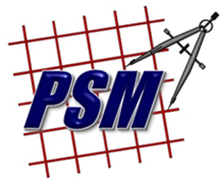
Product No.  PSM-2021-03-001 |  | Product No.  INCOSE-TP-2020-001-06

Editors:
Cheryl L. Jones  US Army  cheryl.l.jones128.civ@mail.mil |  | Geoff Draper  L3Harris Technologies  geoff.draper@l3harris.com
Bill Golaz  Lockheed Martin  willliam.h.golaz@lmco.com |  | Paul Janusz  US Army  paul.e.janusz.civ@mail.mil

Unclassified: Distribution Statement A: Approved for Public Release; Distribution is Unlimited

PSM Product Number: PSM-2020-06-001
INCOSE Product Number: INCOSE-TP-2020-001-06

Copyright Notice:
For this document, each of the collaborative organizations listed on the cover page is the sole manager of their products and services and are the only parties authorized to modify them. Since this is a collaborative product, modifications are managed through the participation of all parties.

General Use: Permission to reproduce, use this document or parts thereof, and to prepare derivative works from this document is granted, with attribution to PSM, NDIA, and INCOSE, and the original author(s), provided this copyright notice is included with all reproductions and derivative works.

Supplemental Materials: Additional materials may be added for tailoring or supplemental purposes if the material developed separately is clearly indicated. A courtesy copy of additional materials shall be forwarded to PSM (psm@psmsc.com, attention: Cheryl Jones). The supplemental materials will remain the property of the author(s) and will not be distributed, but will be coordinated with the other collaboration parties.

Author Use: Authors have full rights to use their contributions with credit to the technical source.

Supplemental Notice from INCOSE: This work is an Affiliate Product per INCOSE Policy TEC-107 INCOSE Technical Product Development & Commercialization (26 October 2018). It is a technical product developed outside the INCOSE product development process and was made by INCOSE members in cooperation with PSM and NDIA; then approved by INCOSE to be distributed from INCOSE central channels. The authors own the copyright and take primary responsibility for proper branding, intellectual property, content quality and appropriate citations with INCOSE oversight based on this policy & related procedure.

Contents
8. Measurement Specifications 1
8.10 Team Velocity (Team Measure) 1

List of Figures
Figure 1: Team Velocity 2

List of Tables
Table 1: Sample Acceleration 2

Measurement Specifications

Team Velocity (Team Measure)
Measure Introduction
Description | Velocity is a measure of team performance and the amount of work that is completed in an iteration, typically a count of completed story points or equivalent. Velocity calculations can be used to estimate the amount of work that can be accomplished by the team in future iterations and when planned deliveries will be completed.
Relevant Terminology | Velocity The average amount of work a team completes in an iteration or release. Used for planning and measuring team performance.  Acceleration Change in velocity across iterations.

Information Need and Measure Description
Information Need | Is the team performing as expected? Does the team consistently meet the anticipated velocity? How much work can be accomplished by the team in a future iteration?
Base Measure 1 | Story Points Completed (integer scale)
Base Measure 2 | Iterations Completed (integer scale)
Derived Measure 1 | Average Velocity = Story Points Completed / Iterations Completed
Derived Measure 2 | Team Acceleration = (Current iteration Velocity – Reference Comparison iteration Velocity) / Reference Comparison iteration Velocity  Note: the Reference Comparison iteration Velocity may be calculated as the Average Velocity across all teams, or by setting a goal for all teams to meet.
Derived Measure 3 | Average Acceleration = Sum (Team Acceleration 1 …Team Acceleration N) / N

Indicator Specification
Indicator Description and Sample | In Figure 1, Story Points Completed is graphed for each iteration [dark blue bars]. Average Velocity is then graphed as of each iteration [red line] based on last 4 iterations (4-iteration rolling average).  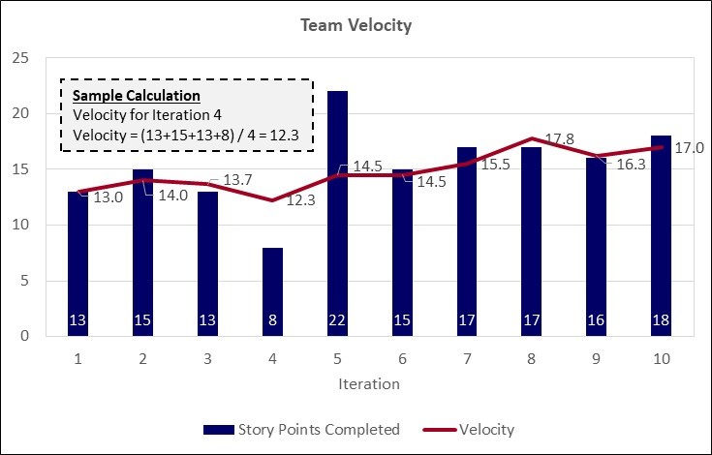  Figure 1: Team Velocity  Table 1: Sample Acceleration  Iteration 4 had a significant drop in velocity, followed by a large increase in iteration 5. This was due to several stories in iteration 4 that had defects. These defects were resolved in iteration 5, along with the completion of the iteration 5 assigned stories. Velocity improved and became more consistent after iteration 5, as the team became more experienced. This team established a consistent velocity after iteration 6.  Changes in velocity across iterations can be analyzed in more detail using acceleration measures. For instance, in Table 1, Teams 1, 2 and 5 show significant positive acceleration, which is typical for early iterations. Team 3 shows a dramatic drop, which should be analyzed to determine if there is a problem. Team 4 shows no variation, which may suggest a reporting anomaly.
Analysis  Model | Do we have a consistent velocity? Why is the velocity changing over time? Based on past performance, is the average team velocity adequate to complete defined features allocated to this team? Variations may occur due to vacations, sick leave, changes to team size/composition, or implementation difficulties.
Decision Criteria | Velocity of +/- 10% should result in analysis at iteration review.

Additional Information
Additional Analysis Guidance | Use this with the Committed Backlog and story point-to-feature ratio to ensure project will release identified features as scheduled (e.g., will velocity for remaining iterations be sufficient to complete committed features)?  Will current average velocity be adequate to complete committed features by end of project? This assumes an ability to estimate average number of story points per feature (and then capability), based on performance. This measure can be used with Reference Comparison iteration Velocity for normalization.  Acceleration can be tracked over time to develop predictive trends in performance. For example, performance tends to increase slowly in the first few iterations, then increase sharply, then plateau. Knowledge of long-term acceleration trends can enhance planning accuracy. Comparing individual team acceleration trends can highlight teams that have problems or that should serve as exemplars. Tracking program level acceleration trends is useful for bidding future work.
Implementation Considerations | In general, velocity is specific to a team and cannot be aggregated across teams to the project level.  If velocity is normalized it can be used at the product or enterprise level.  Usually, velocity should become more accurate and reliable over time as the team becomes more experienced, processes are established, data is regularly produced and reviewed, and the team gets better at estimating.  Since story points may vary across teams, variations in velocity can be compared in percentage terms (positive or negative acceleration relative to prior reference iterations). This gives the program a way of determining which teams are struggling without having to normalize velocities.

Additional Specification Information
Information Category | Process Performance
Measurable Concept | Process Efficiency - Speed
Relevant Entities | Features
Attributes | Stories, Story Points (estimated size)
Data Collection Procedure | Data is collected at the end of each iteration by the team lead from the team tracking tool. Story Points must be tested and satisfy the completion criteria, with no open defects to be counted as completed.
Data Analysis Procedure | Data is analyzed at the end of each iteration by the team during the iteration review and considered during the planning session for the follow-on iteration.

